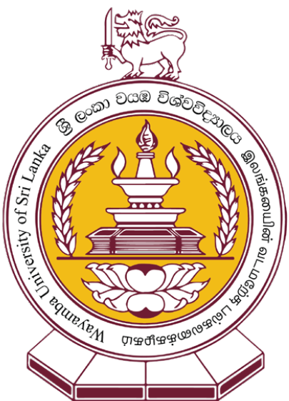
Faculty of Technology
Wayamba University of Sri Lanka
Application for
Diploma in Construction Labour Productivity and Performance Management – 2021/22
(Application Closing Date: 20.06.2021)

- Personal Details

Title (Dr/Mr./Mrs/Miss/Ms/Other)
Full Name

Gender (Please tick) | Male |  |  | Female
Date of Birth (DD/MM/YYYY)
NIC Number
Postal Address
Contact Numbers | Home
 | Mobile
 | Office
Email

- Current Employment Details (Attach copies of certificates/letters)

Designation

Name of the Employer

Project Name
Address of the Current Workplace
Nature of Duties Performed

- Other Work / Training Experience (Attach copies of certificates/letters)

Company /Organization | Designation | Nature of Duties Performed | Period

- Educational Qualification (Attach copies of certificates / results sheets)

GCE Advanced Level | Year(s) of the Examination(s), Subjects and Grades
GCE Ordinary Level | Year(s) of the Examination(s), Subjects and Grades
Other Qualifications | Specify the Institute Names, Qualifications, Subjects, Grades and Year of Completion

- Professional Qualification (Attach copies of certificates)

Specify the Institute Names, Qualifications, Subjects, Grades and Year of Completion

- Other Achievements

- Extracurricular Activities

- Two Non Related Referees

- Name, Designation & Contact Details | - Name, Designation & Contact Details

- Reason for Selecting this Programme
 | Yes | No
I am directly involved in this field.
I am generally interested in the subject.
The course might be helpful for my present employment.
The diploma obtained could be used to further my higher education.
The programme might help me to obtain an employment in the field.
Other (Specify):

- Mode of Payment of Programme Fee

From personal funds |  | By employer |  | Other (Specify)

- Declaration

I do hereby declare that the particulars given in this application are accurate to the best of my knowledge and I am aware that the Wayamba University of Sri Lanka reserves the rights to alter or withdraw any offer made on incorrect information furnished by me.
Date |  | Signature

How did you know about the Diploma in Construction Labour Productivity and Performance Management (DCLPPM) programme?

 | Word of Mouth |  | Newspapers |  | Facebook |  | University Website

 | Seminar |  | Co-workers |  | Company Recommendation

Others (Specify): ……………………………………………..
Application Documents
Attach the following documents with the duly filled application.
- Copy of the NIC
- Photocopy of the birth certificate
- An updated curriculum vitae (CV)
- Photocopies of the relevant certificates/letters (Educational/Professional qualifications, work experience, Etc.)
Note: If the results are pending of any educational qualification claimed in the application form, write a letter addressing to the director mentioning that the relevant examination results are pending and ready to submit soon after the relevant results are released.
- Two recently taken photographs (Passport size)
- Two self-addressed stamped (worth Rs.45/-) 23cm x 10cm envelopes
- Duplicate of the Payment Slip of Rs. 500.00 application fee (Applications without the bank payment receipt will not be accepted)

Application processing fee Rs. 500.00 should be deposited to the below mentioned bank account at any branch of Peoples Bank.
Account Name: Wayamba University of Sri Lanka
Account no: 028 100 1515 86 123 (Current Account)
Bank: Peoples Bank - Kuliyapitiya Branch
Payment type/statement: Application Fee of DCLPPM 2021 - Bank

Duly filled application form with all relevant documents and the duplicate of the payment slip should be posted via registered post to
Director,
Diploma in Construction Labour Productivity and Performance Management,
Faculty of Technology,
Wayamba University of Sri Lanka,
Kuliyapitiya, 60200.

Note: Please mention ‘Application for DCLPPM’ on the top left hand corner of the envelope.
(You are also advised to keep a photocopy of the application and the photocopy of the duplicate of the payment slip)
*Duly filled application forms can be submitted through online with the relevant scanned copies (Send the email to dclppm@wyb.ac.lk with the title ‘Application for DCLPPM <<Your Name>>’).
Application closing date: 20.06.2021

For more details, contact us.
About the application process: Administrative Coordinator (T.P: 0373138054 / 0373976657)
About course information and career advises, contact
Sinhala (0770879053 / 0760122789 / 0714418150) ; Tamil (0774447663 / 0773030266 / 0777678003)
Faculty of Technology, Wayamba University of Sri Lanka, Kuliyapitiya.

