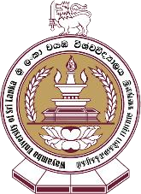
APPLICATION FORM
Individual Applicant Details:

Full name: | Position:
Faculty/Center: | Department/Unit:
Contact number: | Email:

Team Details (Not required for individual award nominations):

Full name | Position | Department/Unit | Faculty | Contact number | Email

Description of the achievement (up to two A4 pages) - Annex additional pages

A brief summary of the achievement that can be used as the awards citation if the nomination is successful (max 100 words):

Supporting comments: (Up to half an A4 page / Max 500 words)

Signature of the Applicant Date

Please annex the following documents:

- Two (2) supporting letters – one each from external stakeholder and internal stakeholders (staff or student) not exceeding two A4 pages highlighting the importance, mutual benefits and impact of the engagement.
- A curriculum vitae of applicant/nominee.
- Evidence for the achievement.

Wayamba University of Sri Lanka Award for Excellence in Community Engagement 2023

